1. A constantly accelerating particle starts from rest and travels for 4 s. If it reaches a velocity of 100 m/s, how far did the particle travel?

(A) 25 m

(B) 50 m

(C) 100 m

(D) 200 m

(E) 400 m

2. An object dropped from a height of 13 m strikes the ground at 16 m/s. In order for the object to strike the ground at 32 m/s, it must be dropped from:

(A) 18 m

(B) 26 m

(C) 39 m

(D) 52 m

(E) 72 m

3. Planets *A* and *B* have the same mass. Planet *A* has a radius half as large as Planet *B*. A 5 kg mass is dropped 10 m above the surface of Planet *A* and at the same time a 5 kg mass is dropped 10 m above the surface of Planet *B*. If the mass on Planet *B* strikes the ground in 10 s, the mass on Planet *A* strikes the ground in:

(A) 2.5 s

(B) 5 s

(C) 10 s

(D) 20 s

(E) 25 s

4. A car moving at 20 m/s brakes and slides to a stop. If the coefficient of kinetic friction between the pavement and the tires of the car is 0.1, how much time is needed for the car to come to a complete stop?

(A) 1 s

(B) 10 s

(C) 20 s

(D) 40 s

(E) 50 s

5. A force of 39.5 N is applied horizontally to a 6.82 N box resting on a table. If friction acts with a force of 2.37 N, what is the acceleration of the box?

(A) 57 m/s2

(B) 62.8 m/s2

(C) 14 m/s2

(D) 73 m/s2

(E) 53.4 m/s2

6. A skier starting from rest descends a 22.1º slope. If the coefficient of friction is 0.194, what is the skier's speed after 8.4 seconds?

(A) 12.3 m/s

(B) 14.5 m/s

(C) 6.10 m/s

(D) 12.9 m/s

(E) 16.2 m/s

7. What is the maximum reading on the scale during a trip from the 5th floor to the 11th floor?

The mass of the elevator and everything in it is 1000 kg. The man in the elevator has a mass of 90 kg. The box that he holds has a mass of 10 kg. The floors of the building in which the elevator operates are separated by 5 m. The elevator accelerates and decelerates at 1 m/s2, and moves at a maximum velocity of 5 m/s. The scale reads in newtons.

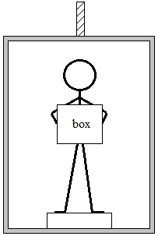

(A) 900 N

(B) 1000 N

(C) 1090 N

(D) 1100 N

(E) 1200 N

8. The airspeed of a plane is 243 km/h and the pilot keeps the plane pointed north. A wind is blowing 71.7 km/h from the west. Determine the speed of the plane relative to the ground.

(A) 60 km/h

(B) 12 km/h

(C) 149.5 km/h

(D) 200 km/h

(E) 253.4 km/h

9. Each of three identical electric heaters is rated at 1000 W when operated across 100 V lines. When the three are connected in series across a 120 V line, at what rate is electric energy converted to heat energy? (Neglect variation of resistance with temperature.)

(A) 0.25 kW

(B) 1.5 kW

(C) 1.2 kW

(D) 3.5 kW

(E) 0.48 kW

10. A 2 kg block requires 2 m to slide to a stop. If the force of friction was 18 N, what was the initial velocity of the ball?

(A) 2 m/s

(B) 4 m/s

(C) 6 m/s

(D) 8 m/s

(E) 10 m/s

11. A vehicle accelerates from rest at 7.08 m/s2 for 3.77 s. What is the final speed of the vehicle?

(A) 16.7 m/s

(B) 5 m/s

(C) 22 m/s

(D) 14.9 m/s

(E) 26.7 m/s

12. The maximum amount of work that can be done by a 60 kW machine in 10 seconds is

(A) 200 kJ

(B) 400 kJ

(C) 500 kJ

(D) 600 kJ

(E) 800 kJ

13. A ball falls from a height of 10 m. If it makes a perfectly elastic collision with the level ground, how high will it bounce? (Assume that the ground is infinitely heavier than the ball)

(A) 0 m

(B) 5 m

(C) 10 m

(D) 20 m

(E) 8 m

14. The crane below uses a steel cable to lift one end of a 1000 kg iron sheet as shown. If the sheet is 10 m long and of uniform density, what is the minimum tension in the cable?

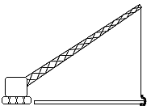

(A) 5000 N

(B) 10000 N

(C) 20000 N

(D) 50000 N

(E) 98000 N

15. 218Po undergoes one alpha decay and two beta decays to make:

(A) 214Po

(B) 214Pb

(C) 214Bi

(D) 210Pb

(E) 218Po

16. Lead has a density of 11.3l03 kg/m3. What is the specific gravity of lead?

(A) 1.13

(B) 11.3

(C) 1.13l03

(D) 11.3l03

(E) 9.8

17. A cylindrical vacuum pump with a cross-sectional area of 1 cm2 is used to lift the mass as shown. What is the greatest mass that the vacuum can lift?

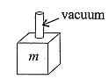

(A) 1 g

(B) 10 g

(C) 1 kg

(D) 10 kg

(E) 20 kg

18. A 2 kg object is at a height of 10 m above the surface of the Earth. If it thrown straight downward with an initial speed of 20 m/s, what will its kinetic energy be as it strikes the ground? (Ignore air resistance.)

(A) 0

(B) 100 J

(C) 200 J

(D) 400 J

(E) 600 J

19. A cylindrical container holds water and Fluid *Z* whose specific gravity is 2. The two fluids are immiscible. The gauge pressure at the foot of the column is 150% of what it would be if all the fluid in the column were water. Fluid *Z* must therefore account for what percentage of the total fluid in the column?

(A) 20%

(B) 30%

(C) 35%

(D) 45%

(E) 50%

20. One of the strings on a certain guitar is 36 cm long. What is the length of the first harmonic for this string?

(A) 18 cm

(B) 24 cm

(C) 36 cm

(D) 72 cm

(E) 80 cm

21. Two oppositely-directed horizontal forces, *F*1 and *F*2, act on a block (of mass 3 kg) which can slide on a frictionless table. *F*1 has magnitude 8 N, and *F*2 has magnitude 20 N. If the block starts from rest, find its speed after 4 seconds.

(A) 4 m/s

(B) 6 m/s

(C) 9 m/s

(D) 12 m/s

(E) 16 m/s

22. What is the voltage across the 2 ohm resistors and the current through either 2 ohm resistors?

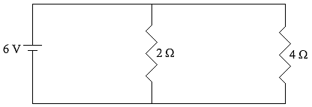

(A) 3 V, 1.5 A

(B) 3 V, 3 A

(C) 6 V, 3 A

(D) 6 V, 8 A

(E) 8 V, 8 A

23. The electric circuit shown below consists of a battery connected in series with 3 resistors. Determine the potential difference across the 4 ohm resistor. (Assume that the battery has no internal resistance.)

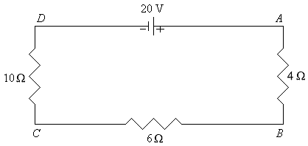

(A) 1 V

(B) 4 V

(C) 10 V

(D) 20 V

(E) 40 V

24. When two identical resistors are connected in series across a battery, the total power dissipated by them is 20 W. If these resistors are connected in parallel across the same battery, the total power dissipated is

(A) 50 W

(B) 80 W

(C) 20 W

(D) 40 W

(E) 120 W

25. Three resistors are connected to a 1.0 V battery, as shown in the diagram below. What is the current through the 2.0 Ω resistor?

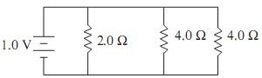

(A) 0.25 A

(B) 2 A

(C) 1 A

(D) 0.5 A

(E) 4 A

26. The equivalent resistance between points *A* and *B* is

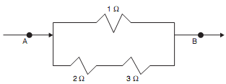

(A) $\frac{2}{3}$ Ω

(B) $\frac{5}{6}$ Ω

(C) 1 $\frac{1}{6}$ Ω

(D) 1 Ω

(E) 2 Ω

27. A galvanometer has an internal resistance of 200 Ω and requires a current of 5 mA for full-scale deflection. What resistance should be connected in parallel with this galvanometer so that it reads 10 A at full-scale deflection?

(A) 0.1 Ω

(B) 4×105 Ω

(C) 400 Ω

(D) 0.2 Ω

(E) 2 Ω

28. A proton and an electron are separated by a distance of 3 cm as shown. The electrostatic force between them is



(A) –2.56×10–29 N

(B) –2.56×10–25 N

(C) +2.56×10–29 N

(D) –2.56×1029 N

(E) +2.56×1029 N

29. A positively charged particle enters a magnetic field directed out of the page. If the charge enters from the left, as shown, the resulting force is directed



(A) Toward the top of the page.

(B) Toward the left.

(C) Out of the page.

(D) Toward the bottom of the page.

(E) Into the page.

30. The equivalent capacitance of this circuit is nearest to

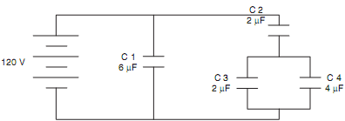

(A) $\frac{5}{6}$ µF

(B) $\frac{6}{5}$ µF

(C) 7 µF

(D) 7.5 µF

(E) 10.5 µF